Do all the courses

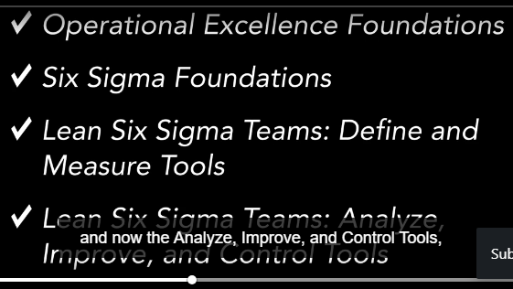

Six Sigma is a set of methodologies and tools used to improve business processes by reducing defects and errors, minimizing variation, and increasing quality and efficiency

## Terminologies:

1) waste is anything that is of no value to cusotmers

2) Lean is all about --> eliminating waste and maximizing value to customers

To be lean means provide what is needed when it is needed, with minimum amount of materials

equipment, labour,space,

3) project charter: what we need is called project charter, it is a document that provide

direction and focus to project team

it tells the purpose, goal ,scope of the project

4) SIPOC -supplier, input,process, output, customer

why? to understand high level view of process

DMAIC-

Define

Measure

Analyze

improve

control

Lean six sigma

=========

customer focus

effectiveness & efficient processes

proactive prevention and control

Project charter

==============

1)that doc should contain what we need,

2)it should display SMART goals- s-specific,M-Measurable,A-attainable,R-Relevant, T-Timebound

3) it should contain--> problem statement, goal statement,key metrics, financial benefits, project scope, what is out of scope, project boundaries, milestones, completion dates

(performance measure to be improved)

if u dont understand what is out of scope, then u will fell into project creep ,means unknwoingly increase of project scope

value: this is what cusotmers need, expect, and willing to pay for

Bottleneck or constraints:- slowest processing step of a value stream

six sigma strives for perfection, achieve efficiency & effective work

SIPOC

========

to understand high level view of process

SIPOC -supplier, input,process, output, customer

process:- take order, prepare pizza, bake pizza, box it, deliver to customer

Supplier- is any one who provides the inputs to the process ex:- flour mills,ingredient suppliers

input:- flour, masalas,

output: pizza

cusotmers- who is going to eat

VOC:- voice of customer/ Customer satisfaction survey

cusotmer is anyone who are utilizing our services

CTQ

=====

are Critical to Quality requirements:- performance charecterstics that are critically important to customers

Cost of poor quality

===================

means the costs occurred due to poor performance

These things can be avoided if things were done right at first time

Demo:-

-----

demo using swim lane process map (using flow charts), these process maps contain small few major steps

Measure phase

================

1) determine what is critical to customers

2) develop a data collection plan for measuring

### Process maps

1) high level process map (displays main activities inside a process)

2) swim lane (if multiple groups are involved, then use swim lane process maps)

3) Detailed

4)value stream

1) High level process maps

contains only major activities ex:- comunicating with fiserv, creating an react page,storing in sql server

like checkin, see doctor,checkout ,pay

if u want to know more, then create detailed individual process maps

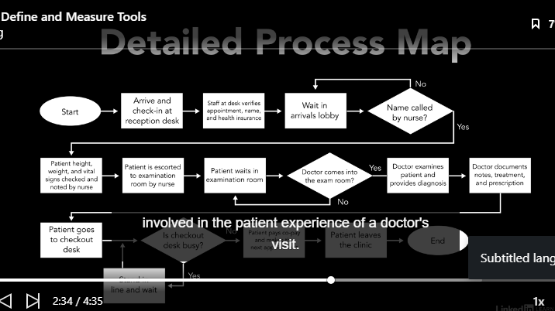

**Swim lane process map**

**A SWIM lane process maps tells which group is performing each process step**

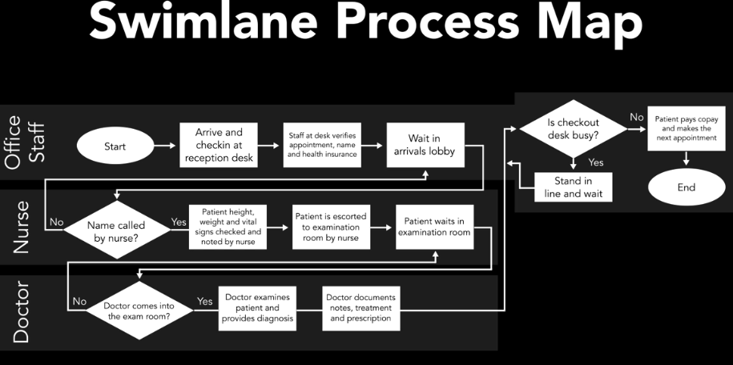

What is value:

Value is what’s important to customers

### Values stream maps

All end to end process activities, resources, information used to transform inputs to outputs that are salable to customers

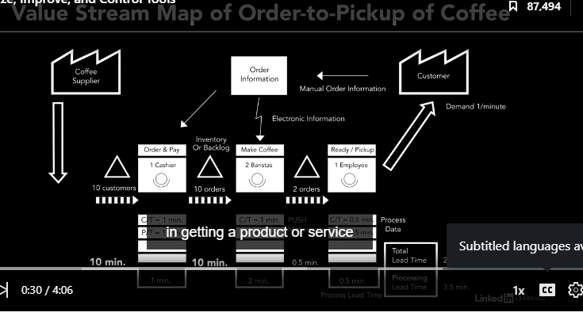

Cause effect diagram

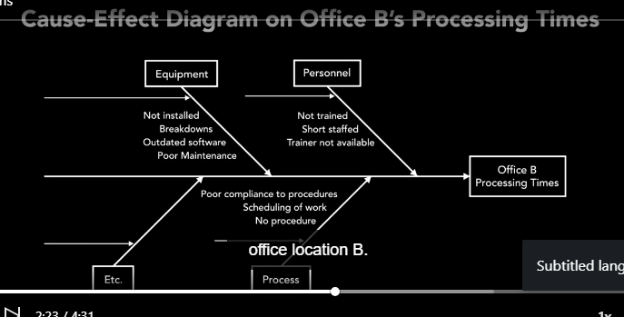

Failure modes and effects analysis

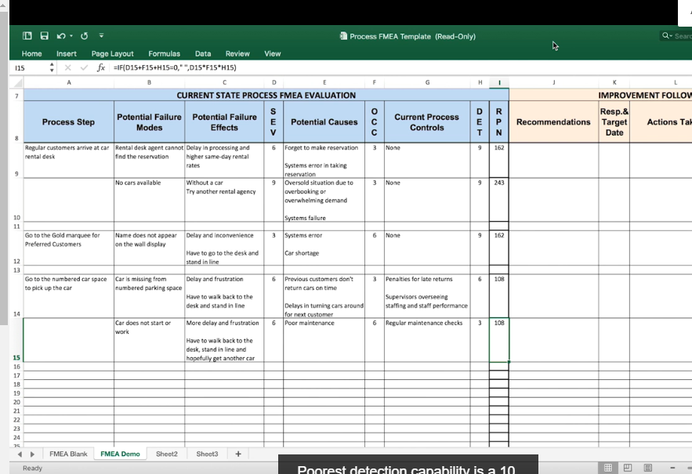

Criteria selection matrix

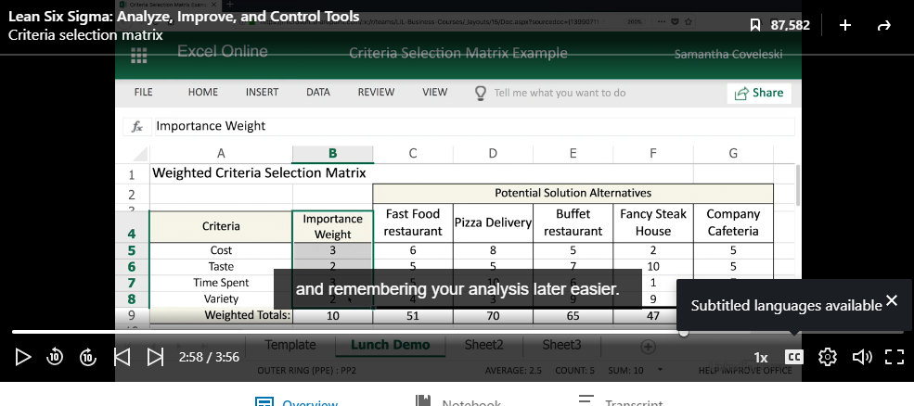

Every criteria have some weightage, u have to choose the best alternative by writing on a sheet

Pugh selection matrix

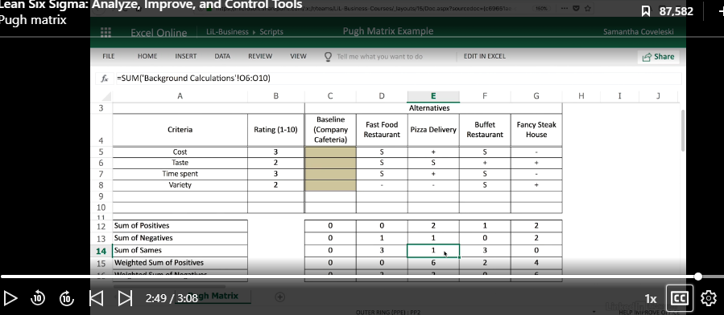

Process control plan

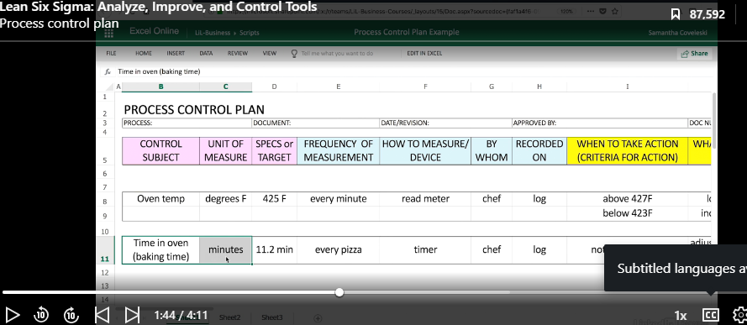

It says what to watch and when to watch & what action to take

